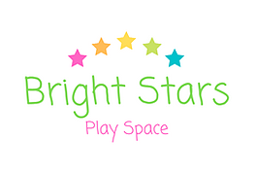

Welcome to Bright Stars Play Space
Here are some important notes For Parents/Carers:
- At Bright Stars Play Space adults are responsible for their children at all times including during sessions and in the downstairs Play Space. Supervision is the full responsibility of the adult accompanying the child.
- All classes are to be paid for online prior to attending the session. Transfers and refunds will not be given. Any classes that are missed will not be refunded or added to other blocks bookings.
- All our sessions are baby and toddler led so if you need to feed or change your baby at any time please do so in a space you feel comfortable. We have a number of spaces where you can do this including baby changing facilities.
- Photos are encouraged at Bright Stars Play Space; they are a great way of capturing memories. Please remember to only take photos of your own child. It would be great to see the images of your child enjoying Bright Stars on social media.
- Bright Stars Play Space does not accept responsibility for loss or damage to personal belongings.
- Bright Stars Play Space will remain open whenever possible but in the event of closure due to adverse weather or illness you will be informed via email and on our Facebook page. Any sessions missed will be reimbursed in full as this is out of your control.
- If you or your child are ill, please do not attend the Play Space until you are fully recovered or no longer contagious. Please see the NHS website for medical advice.
- Our Play Space is set over two levels please email to let us know if there is a specific reason you cannot partake in sessions on the first floor and we will make adaptations.
- All our sessions must be booked online. Spaces are limited so please use the waiting list option if your chosen class is full.

If you have any questions, please do not hesitate to contact us on admin@brighstarsplayspace.com

